

IT3060 - Human Computer Interaction

Assignment 2

Project title: Low Fidelity Prototyping

**Craigslist.org**

Group number: 2023-WE-S1-13

Group name: DreamWeave

**Member Details**

|  |  |  |
| --- | --- | --- |
| **Reg. No** | **Name** | **Work Distribution** |
| IT21181474 | Hettiarachchi H.K.Y. K | * Account Login * THIS BEAUTIFUL COMBINATION FIREPLACE / 8-TRACK STEREO! * Password Options |
| IT21360046 | Jayasekara B.B.R. Y | * Profile * Contact us. * Community |
| IT21358616 | Munasingha M.H.C | * For sale * About * Services |
| IT21356636 | Perera P.K. L | * Post type and category page * Post details fill page. * Unpublish draft page |
| IT21345746 | Siriwardana A.P.G.D. P | * Homepage * Housing * Events |

**Table of Contents**

1. Video Transcripts of 3 Users 3

2. Usability Issues 3

3. Variants of the Interfaces 4

4. Justification of the variants 5

5. Ideation techniques used 10

6. How the best design was selected 11

7. Time Schedule 15

8. References 16

9. Appendix 17

9.1 Transcripts 17

9.1.1 Novice seller 17

9.1.2 Hotel manger 19

9.1.3 Undergraduate student 21

9.2 Variants 23

9.2.1 Account Login variant 1 23

9.2.2 Account Login variant 2 24

9.2.3 HIS BEAUTIFUL COMBINATION FIREPLACE / 8-TRACK STEREO! variant 1 25

9.2.4 THIS BEAUTIFUL COMBINATION FIREPLACE / 8-TRACK STEREO! variant 2 26

9.2.5 Password option variant 1 27

9.2.6 Password option variant 2 28

9.2.7 Contact us variant 1. 29

9.2.8 Contact us variant 2. 30

9.2.9 Community variant 1 31

9.2.10 Community variant 2 32

9.2.11 Profile variant 1 33

9.2.12 Profile variant 2 34

9.2.13 For sale variant 1 35

9.2.14 For sale variant 2 36

9.2.15 Services variant 1 37

9.2.16 Services variant 2 38

9.2.17 About variant 1 39

9.2.18 About variant 2 40

9.2.19 Post type and category variant 1 41

9.2.20 Post type and category variant 2 42

9.2.21 Post details fill page variant 1. 43

9.2.22 Post details fill page variant 2. 44

9.2.23 Unpublish draft page variant 1 45

9.2.24 Unpublish draft page variant 2 46

9.2.25 Homepage variant 1 47

9.2.26 Homepage variant 2 48

9.2.27 Housing variant 1 49

9.2.28 Housing variant 2 50

9.2.29 Events variant 1 51

9.2.30 Events variant 2 52

## Video Transcripts of 3 Users

|  |  |
| --- | --- |
| **User** | **Transcript** |
| Novice seller | Video transcript |
| Hotel manager | Video transcript |
| Undergraduate student | Video transcript |

## Usability Issues

|  |  |  |
| --- | --- | --- |
| **High** | **Medium** | **Low** |
| * Page contents are complex. * Not user friendly. * Hard to find information quickly because of no highlights. * Users can also delete information. * Confusing filtering system. | * Fonts are too small. * Unclear information * This site is very racking. * Confusing content because links are everywhere. | * Not attractive. * No graphics |

## Variants of the Interfaces

|  |  |  |  |
| --- | --- | --- | --- |
| **IT Number** | **Interface name** | **Variant 01** | **Variant 02** |
| IT21181474 | Account Login | Account Login variant 1 | Account Login variant 2 |
| THIS BEAUTIFUL COMBINATION FIREPLACE / 8-TRACK STEREO! | THIS BEAUTIFUL COMBINATION FIREPLACE / 8-TRACK STEREO! variant 1 | THIS BEAUTIFUL COMBINATION FIREPLACE / 8-TRACK STEREO! variant 2 |
| Password Options | Password Options variant 1 | Password Options variant 2 |
| IT21360046 | Contact us | Contact us variant 1 | Contact us variant 2 |
| Community | Community variant 1 | Community variant 2 |
| profile | profile variant 1 | profile variant 2 |
| IT21358616 | for sale | for sale variant 1 | for sale variant 2 |
| service | service variant 1 | service variant 2 |
| about | about variant 1 | about variant 2 |
| IT21356636 | Post type and category page | Post type and category page variant 1 | Post type and category page variant 2 |
| Post details fill page | Post details fill page variant 1 | Post details fill page variant 2 |
| Unpublish draft page | Unpublish draft page variant 1 | Unpublish draft page variant 2 |
| IT21345746 | Homepage | Homepage variant 1 | Homepage variant 2 |
| Housing | Housing variant 1 | Housing variant 2 |
| Events | Events variant 1 | Events variant 2 |

## Justification of the variants

|  |  |  |
| --- | --- | --- |
| **IT Number** | **Interface name** | **Justification** |
| IT21181474 | Account Login | **In variant 1,** I used placeholder texts and image icons for Email/ Handle and Password for the login frame with the main reason that users can easily login to the system with an eye-catching page background. Not only that, but also, I used placeholder texts and image icons for Email for the Create account frame also for the above-mentioned reason. When seeing the “Account Login” original page every time users have to read the content to login or create their accounts. But with this new variant user can quickly and easily login or create their accounts.  Addition to that, I add some font colors, font sizes according to the important points of the content and replace white spaces of the content to get more user attraction.  **In variant 2,** With this variant, I add some font colors, font sizes according to the important points of the content to get more user attraction. |
| THIS BEAUTIFUL COMBINATION FIREPLACE / 8-TRACK STEREO! | **In variant 1,** I used video to inform the users to combine the fireplace with an eye-catching page background. When seeing the content in the “THIS BEAUTIFUL COMBINATION FIREPLACE / 8-TRACK STEREO!” original page users have to click the images one by one to see the combination of the fireplace. And I added a button to replace the link of print. Because it is not visible enough for the users when considering the original page.  Furthermore, I add some font colors, font sizes according to the important points of the content and replace white spaces of the content to get more user attraction. And I add two extra buttons to go forward and go to the Best of Craigslist page.  **In variant 2,** I added a button to replace the link of print. Because it is not visible enough for the users when considering the original page.  Furthermore, I add some font colors, font sizes according to the important points of the content to get more user attraction. |
| Password Options | **In variant 1,** I used placeholder texts and image icons for new Passwords and re-types of new Passwords for the set a password with the main reason that users can easily login to the system with an eye-catching page background. When seeing the “Password Options' ' original page every time users have to read the content to set a password. But with this new variant user can quickly and easily set a password.  Addition to that, I add some font colors, font sizes according to the important points of the content and replace white spaces of the content to get more user attraction.  **In variant 2,** With the 2 variants of the Password Options page, I add some font colors, font sizes according to the important points of the content to get more user attraction. |
| IT21360046 | Contact us. | In both variants (**variant 1 and variant 2**), there is a "page title" on the top of the web page, but in variant 1 "page title" is very clear and can be understood quickly but variant 2, "page title" is not clearly understood for users. (The purpose of the web page). In variant 1, there is a Google Map top of the page, it can find location very easily and variant 2, does not have any Google Map, it contains only addresses. In Variant 2 contact details shown in words only (such as phone, email, location) but variant 1, use standard symbols to denote the contact details more attractively. Both variants have a simplest contact form with necessary input fields but in Variant 1, contact form provide hints to fill the form easily and variant 2, use la-bales only |
| Community | **In variant 1**, I use community categories as a topic. By clicking one topic, users can view related product items. Under that topic, I put categories with details. In this way community and details can be seen on that page. I put "Page navigation bar" under those. By clicking page navigation bar, user can view more categories with details.  **In variant 2**, there is a simple and small product image in the left corner of the page. Variant 2, clearly mention all the details using separate titles using correct alignments.( product code , categories , availability)but variant 2 , mention some of the product details bottom of the page.(price ,code , quantity).Variant 2,give more product details using point form it’s easy to understand and read for users and give more product details in a description so it is hard to read and understand. And, Variant 2, displayed related products according to the chosen product but in Variant 1 does not display and related products |
| IT21358616 | for sale | **In variant 1:** I use picture for cover the half of the screen in right side. Picture is not changing. It’s like an advertisement. I put the selection box to select category on the left-hand side of the picture. I use another picture on the right under the cover photo. Then I put a topic called for sale category. By clicking one selection box, user can view related sale item. Under the picture and selection box, I put image of the sale items. I decide to put sale item price and small description under the image. In this way sale item images and details can be seen on that page and, I put navigation button. By clicking page navigation bar, user can review more sale items.  **In variant 2:** I use the imagefor cover the whole screen. Under the image I put the category to the for-sale items. In that part, I use three selection buttons. Then I called “most popular”, “hot selling”, “best review” that button. I put banner right side that selection buttons. By clicking selection button, user can see related item category box. Then user can select item that selection box. In this way sale item and details can be seen on that page. Another selection boxes are same way. |
| service | **In variant 1**: I will use for cover photos right of the page. It is changing likes slide slow. I put selection boxes to select service category on right hand side of the photos. Under the category list and photos, I use advertisement banner. Under the banner I use selection box to the service category. Then user select what type of category user can navigate other page. That page user can see service description, service time etc.  **In variant 2:** This is a same in variant1 service page. But cover photo is cover the whole screen. I did not add the category list, but all service is viewing this page. |
| about | **In variant 1:** I use the image top of the page and there’re huge paragraph about the website service and product under the image. Clear paragraph about service product separately. Under the paragraph I use the same size description box and image. Description box have included in other features.  **In variant 2:** I use the image whole screen. I use four categorical as a topic. User can click topic and navigate user of that topic. I use small description to describe this web site and other details. Under the description I decide to put the picture of the who are the operators and manage this site. |
| Post details fill page | **In variant 1**: I will use for this three input text boxes for align left, align center, and align right of the screen. The left text box is added to the post title. Center text box for adding to city or neighborhood and right text box for postal code. I put a text area for adding description for our services to it. I use two panels for one is post details it has check boxes and another panel for contact details.  I will add for the file uploader to this page the original content it has not image uploader for this page. I add to text area for this it’s describe the things you want to add.    **In variant 2:** I use text area it’s display the instructions you follow into posting before. Add three text boxes like previous variant 1. After I add text area for type description. I am adding a panel for the left side it’s included contact information. I use dummy text for adding some information. Another panel has been established on the right side of the web page and it’s used to post details. Additionally, I will add to notice area for this. All the details fill in after clicking the done button. |
| Unpublish draft page | **In variant 1:** I use search bar for this page. On the previous page we uploaded a picture it is show for this page it is show in the left side on our page.  I add mock text for its show the details of the created post it has been established in center of this page. After I added two buttons. First is the edit image button you can click and edit the picture in this page. The second button is the editing post button you can click an edit or delete this post in our website. All the things are finished you can publish the post on our website by clicking the submit button.  **In variant 2:** I use the profile icon it’s show into your profile it has been established in right top of the corner in page. Add to search bar for this and middle of the page show picture. On the left side on the page, I add details about the post. On the right side I add contact details. Left top of the corner I will add edit image button and right down of the corner I will add edit post button. |
| IT21345746 | Homepage | **In variant 1**, I used an image slider to add more attraction to the homepage background. If we see the original content in the craigslist website there are no images, or any background colors and it’s filled with texts and links. Instead of adding the same I used that image slider with quick accessing links for each link in the original page.  For a brief introduction about the content, I put some extra text links with some styles after the image slider. That text can collapse after clicking the collapse icon. I hope to add more colors for the given design but since this is a sketch it used to look like this.  Also, there was not any header or footer, So I added a header and footer with some links. The search icon also replaces in the middle of top of the webpage. And the app button was also replaced to get more attention.  **In variant 2**, Instead of using an image slider I put links with images and some introduction with explore button. Also, there is a head topic in the page. Each explore button will take you to the relevant pages. |
| Housing | **In variant 1**, I used items to be displayed as grid, gallery, list, map, and thumbnail views easily via the top right sided icon. And it only shows a preview of items. And the filtering system also replaced in the top and sorting can be done as newest and oldest that is also replaced.  And the price can be adjusted by given inputs or customers can manually add price and look for sale items that are suitable for that price.  **In variant 2**, Changed the items view only for viewing as detailed one with images.one sale item can have many images so it will display within an image slider. Topics and additional descriptions are allowed here, and each item will be displayed in the whole page. Customers can search for their preferred housing item.  To go to the next item, customers must click on the page slider in the bottom of the page, and it shows the number of items(pages) that contain the filtering system. |
| Events | **In variant 1,** also the page items can be displayed as grid, gallery, list, map, and thumbnail views. It shows a preview, and the calendar allows you to look for events that are scheduled each day. And the checkboxes can be selected as customers wish.  **In variant 2,** only allows one event per page and all the information is displayed in each page. No previews, no multiple images are allowed. Page slider is available. |

## Ideation techniques used

|  |  |
| --- | --- |
| **IT number** | **Ideation technique** |
| IT21181474 | Round Robin  Brainstorming  Brainwriting  Sketching |
| IT21360046 | Round Robin  Brainstorming  Brainwriting  Sketching |
| IT21358616 | Round Robin  Brainstorming  Brainwriting  Sketching |
| IT21356636 | Round Robin  Brainstorming  Brainwriting  Sketching |
| IT21345746 | Round Robin  Brainstorming  Brainwriting  Sketching |

## How the best design was selected

|  |  |  |
| --- | --- | --- |
| **IT Number** | **Interface name** | **Best Design** |
| IT21181474 | Account Login | I chose **Account Login variant 1** as the final design of the Account Login Page. According to my and our group members' opinions, in the variant 1 users can easily and quickly view and login or create their accounts rather than the variant 2 due to placeholders and image icons in the page. And there are no more white spaces with the boring background in variant 1. So, it can get more user attraction also when considering both variants. |
| THIS BEAUTIFUL COMBINATION FIREPLACE / 8-TRACK STEREO! | I chose **THIS BEAUTIFUL COMBINATION FIREPLACE / 8-TRACK STEREO!**  **variant 1** as the final design. According to my and our group members' opinions, in the variant 1 users can easily view the images of the fireplace, and it is more eye-catching than the variant 2. Because there are no more white spaces with the boring background. And users can easily and quickly refer to the other pages also with this variant due to the forward and best of Craigslist page button. |
| Password Options | I chose **Password Options** **variant 1** as the final design. According to my and our group members' opinions, in the variant 1 users can easily and quickly view and set a new password rather than the variant 2 due to placeholders and image icons in the page. And there are no more white spaces with the boring background in variant 1. So, it is the most eye-catching one also when considering both designs. |
| IT21360046 | service | **In variant 1**: I will use for cover photos right of the page. It is changing likes slide slow. I put selection boxes to select service category on right hand side of the photos. Under the category list and photos, I use advertisement banner. Under the banner I use selection box to the service category. Then user select what type of category user can navigate other page. That page user can see service description, service time etc.  **In variant 2:** This is a same in variant1 service page. But cover photo is cover the whole screen. I did not add the category list, but all service is viewing this page. |
| about | **In variant 1:** I use the image top of the page and there’re huge paragraph about the website service and product under the image. Clear paragraph about service product separately. Under the paragraph I use the same size description box and image. Description box have included in other features.  .    **In variant 2:** I use the image whole screen. I use four categorical as a topic. User can click topic and navigate user of that topic. I use small description to describe this web site and other details. Under the description I decide to put the picture of the who are the operators and manage this site. |
| service | **In variant 1**: I will use for cover photos right of the page. It is changing likes slide slow. I put selection boxes to select service category on right hand side of the photos. Under the category list and photos, I use advertisement banner. Under the banner I use selection box to the service category. Then user select what type of category user can navigate other page. That page user can see service description, service time etc.  **In variant 2:** This is a same in variant1 service page. But cover photo is cover the whole screen. I did not add the category list, but all service is viewing this page. |
| IT21358616 | for sale | **Variant 1:** Variant 1 is the variant I've chosen as the finest because it features a straightforward, compact graphic that is user-friendly. Read reviews from customers to rapidly understand the product's features since all the information is presented properly and in the proper alignments. Since the product details are presented in point form, users may recognize them quickly and accurately. |
| service | **Variant 1:** I chose variant 1 of these interfaces after weighing its differences and similarities to the other variants. Compared to Variant 1, it looks better. |
| about | **Variant 1:** Variant 1 is the finest, in my opinion, because it includes company facts in brief, distinct phrases that are easy to understand. Users will have no trouble understanding it. According to those two paragraphs, there are two main, distinct titles: "Our Products" and "Our Services." It helps users to quickly, accurately, and thoroughly understand the organization. |
| IT21356636 | Post type and category page | **Post type and category page Variant 2:** I decided to choose variant 2. According to my opinion variant2 sketch is creative than variant 1 sketch. When I ask usability issue in the page User said font size are small and difficult to read, all the data like cluster. So, I decide to fix them, and I build this more attractive. It’s successfully overcome usability issues that user mentioned. |
| Post details fill page | **Post details fill page** **Variant 2:** considering the difference and similarities in the two variants of this interface, I selected variant 2. it’s looks more attractive than variant 1. Font colors are also used in the proper way. All the content is in well-structured design. It’s user friendly. |
| Unpublish draft page | **Unpublish draft page Variant 2:** I have chosen variant 2 as the best interface. It’s user friendly for user. All the service details are mentioned clearly. It’s quickly understood to user to about the service. And it is user friendly interface and user can edit of delete this post easily. |
| IT21345746 | Homepage | I choose the **Homepage variant 1** as the final design. In my opinion, it is clearer and more understandable for everyone than the Homepage variant 2. The interface would be more attractive after designing like this. The present website has a lot of listings so as the 2nd variant I think it’s not a clever idea to again design the website with more lists if it contains images. The homepage should be paid more attention because it is the first and most important page in a website to attract customers, so it should be short and less detailed. So, my best choice is **Homepage variant 1**. |
| Housing | I choose the **Housing variant 1** as the final design. In my opinion it is adjustable (customers can view the items in many views). I Think it will be easier. This interface is more user friendly more than the 2nd variant because the 2nd variant can only views as the whole one for some people it may be disturbance. The whole view can't adjust, or they need to slide each page for each item. The search is also there but I think the 1st variant is more comfortable. Someone who using mobile phones are also can satisfied with this previewed section. The responsiveness is more usable in a view like this. |
| Events | I choose the **Events variant 1** as the final design. In my opinion it is also easily responsive in a mobile view/PC view or other devices. After adjusting the calendar and other filters customers can clearly see the filtered items in a one interface in the 1st variant. But the 2nd variant is not allowing to see every item in a one page it should be slide each page. It is not very much user-friendly. Instead of doing that hard work I recommend the 1st method is more satisfying and easily scrollable. And Grid view, list view, thumbnail view, map view and gallery view can be applied here as the customers wish. So, I think the best option is the **Events variant 1**. |

## Time Schedule

|  |  |  |  |  |  |  |  |  |  |  |  |  |  |  |
| --- | --- | --- | --- | --- | --- | --- | --- | --- | --- | --- | --- | --- | --- | --- |
| **Task** | **Weeks** | | | | | | | | | | | | | |
| **01** | **02** | **03** | **04** | **05** | **06** | **07** | **08** | **09** | **10** | **11** | **12** | **13** | **14** |
| Group registration and project topic selection |  |  |  |  |  |  |  |  |  |  |  |  |  |  |
| Identifying usability issues of the website |  |  |  |  |  |  |  |  |  |  |  |  |  |  |
| Designing 3 Personas |  |  |  |  |  |  |  |  |  |  |  |  |  |  |
| Scripting contextual inquiries |  |  |  |  |  |  |  |  |  |  |  |  |  |  |
| Documentation |  |  |  |  |  |  |  |  |  |  |  |  |  |  |
| Activity 1 submission |  |  |  |  |  |  |  |  |  |  |  |  |  |  |
| Designing sketches |  |  |  |  |  |  |  |  |  |  |  |  |  |  |
| Justify the Pros and Cons |  |  |  |  |  |  |  |  |  |  |  |  |  |  |
| Identify the techniques |  |  |  |  |  |  |  |  |  |  |  |  |  |  |
| Planning |  |  |  |  |  |  |  |  |  |  |  |  |  |  |
| Documentation |  |  |  |  |  |  |  |  |  |  |  |  |  |  |
| Activity 2 submission |  |  |  |  |  |  |  |  |  |  |  |  |  |  |
| Design High Fidelity Prototype |  |  |  |  |  |  |  |  |  |  |  |  |  |  |
| Making video demonstration |  |  |  |  |  |  |  |  |  |  |  |  |  |  |
| Implement the project |  |  |  |  |  |  |  |  |  |  |  |  |  |  |
| Activity 3 submission |  |  |  |  |  |  |  |  |  |  |  |  |  |  |
| Making Final Project |  |  |  |  |  |  |  |  |  |  |  |  |  |  |
| Final Presentation |  |  |  |  |  |  |  |  |  |  |  |  |  |  |
|  |  |  |  |  |  |  |  |  |  |  |  |  |  |  |

## References

* [**https://www.justinmind.com/ui-design/sketching#:~:text=The%20first%20step%20to%20making,within%20in%20the%20project%20context**](https://www.justinmind.com/ui-design/sketching#:~:text=The%20first%20step%20to%20making,within%20in%20the%20project%20context)**.**
* [**https://www.bing.com/search?q=ideation+techniques+or+tools&qs=UT&pq=ideation+techniques&sk=MT2UT3&sc=10-9&cvid=78FFCFA1AA484EA69BE06BB9BAE20503&FORM=QBRE&sp=6&ghc=1&lq=0**](https://www.bing.com/search?q=ideation+techniques+or+tools&qs=UT&pq=ideation+techniques&sk=MT2UT3&sc=10-9&cvid=78FFCFA1AA484EA69BE06BB9BAE20503&FORM=QBRE&sp=6&ghc=1&lq=0)

## Appendix

### Transcripts

#### Novice seller

**A – Interviewer**

**B – Novice seller**

[0.00.05] A: Good morning, Anishka

[0.00.07] B: Good morning

[0.00.09] A: Thank you for joining with us for our meeting. Shall we move to the site?

[0.00.16] B: Ok

[0.00.19] A: How often do you use our website?

[0.00.23] B: I use this website twice a week.

[0.00.30] A: Ok what do you think about our facilities are they user-friendly?

[0.00.38] B: Umm. now, it’s not very user friendly. its

[0.00.44] A: Why are you telling it's not user friendly,

What are the reasons?

[0.00.49] B: Umm. it's not very colorful one, not attractive and it's very hard to find what I want, most important ones are not highlighted.

[0.01.05] A: Ok so when you are using it. What is your main problem according to our site?

[0.01.16] B: Urh. There are lot of information I can’t find very well.

It’s not attractive.

Most contents are complex.

[0.01.32] A: So, what kind of improvements do you wish to have in our website.

[0.01.39] B: Urh most importantly It's very...It want to colorful and attractive to user to

Important ones very easy to find you should do it.

[0.01.56] A: Ok, so can you move to the post?

[0.02.03] B: yes ok

[0.02.05] A: Yes post

[0.02.12] select whatever you prefer.

[0.02.13] B: How

[0.02.15] A: Anything you can select.

[0.02.21] B: Ok

[0.02.22] A: Yes, then continue.

[0.02.34] You can fill the form.

[0.02.42] B: Ok

[0.02.45] A: What are you think about that design, is it easy to post something, or is that difficult.

[0.02.45] B: No, it’s hard to find important ones and letters topics are very small umm.... Thats it

[0.03.11] A: Ok so let's move to the housing.

[0.03.14] B: Ok

[0.03.26] A: Do you think the filtering system is enough to fulfill your Satisfaction. I mean this left Side.

[0.03.27] B: No, this information is not enough for me.

Functions are very hard to find.

Complexity

If I click hiding option, it’s also ads deleting.

It's umm. I think it's an issue of your website.

[0.04.06] A: Ok So Let's go to the homepage again.

[0.04.11] B: Ok

[0.04.16] A: Let's go to the community.

[0.04.27] you can see the page. is also empty, so do you recommend if we add Some graphics or some colorful background to this page? Is it usable?

[0.04.42] B: Yes, the community page is also, need to very Colorful, and very user friendly and designs are very colorful, but this site is not very colorful. This is a basic level webpage.

[0.05.09] A: Ok, let's go again home page.

[0.05.10] B: Ok

[0.05.16] A: Thank you for your reviewing, and how do you rate our website.

[0.05.24] B: I give you 2/5

[0.05.33] A: Thank you let's see what we will improving, thank you for joining with us see you.

[0.05.42] B: Ok thank you.

#### Hotel manger

**A – Interviewer**

**B – Hotel Manager**

[00.00.06] A: Hello Good Morning! Mr. Sandalu.

[00.00.10] B: Good Morning.

[00.00.12] A: Thank you so much your time to speech us today. Shal, we move into the site.

[00.00.23] B: Okay.

[00.00.29] A: Tel me about how often do you use the website?

[00.00.34] B: I think four or five times I interact with this site.

[00.00.43] A: What kind of device did you choose for website to use?

[00.00.47] B: First I will use my personal phone and I will use my laptop.

[00.01.02] A: Okay. What are the problems do you face to suffering in this website?

[00.01.07] B: There are so many problems in this website. Like no highlight’s topic, there are no colorful and I can’t read this because this is a so many ugly. There are so many problems first I noted special point there are no highlights in this.

[00.01.38] A: It is user friendly or not?

[00.01.43] B: Not user friendly.

[00.01.53] A: what is your opinion of the design for the website?

[00.01.59] B: I think first we can add colors and we want to highlight topics special points. And build up again.

[00.02.46] A: For what is the purpose of using this website?

[00.02.53] B: this site I use for finding jobs.

[00.03.14] A: what did you think in facilities in this website what are the improve?

[00.03.28] B: first you want to improve the UI UX part, because there is no user friendly for this and we want to categorize this like we can get navigation bar and categorize in jobs, house, sales like this and we can highlight topics like colorfully., add pictures for this.

[00.04.23] A: Can you share screen and show the website.

[00.04.33] B: Sure.

[00.04.51] A: you can go to the jobs category in website, what is the problem for this page?

[00.04.59] B: there are no good filtering system, not colorful we can’t filter like I want to find job in management post but there are not good manager post jobs in this page. We improve this and we can add pictures and we can rate this job.

[00.05.40] A: can you go for the services page? What is the error for this page?

[00.06.14] B: on this page I don’t use very much but I can see there are no colorful and these words are like so ugly. In this page we can colorful, and we can rate these services like 1/10 marks. We can add them as a filtering system like jobs, services we can filter like I think like job I want to search for software engineering we can filter it and we can get it.

[00.07.04] A: Have you used this website in your mobile phone?

[00.07.09] B: Not too much but little bit

[00.07.17] A: Actually, mobile response this website?

[00.07.25] B: yes, but not good satisfaction for this because so many ugly. I can’t find lot of things in mobile application.

[00.07.43] A: finally, can you give me feedback for this website?

[00.07.54] B: I think this website I can’t give good feedback this is very bad website, it’s very ugly I give a one star for the website, and this is not user friendly there are so many errors for this.so it’s my feedback.

[00.08.16] A: okey. I got it thank you for your time.

[00.08.24] B: Thank you.

#### Undergraduate student

**A – Interviewer**

**B – Undergraduate Student**

[00.00.06] A: Hello Good Evening Bhanuka.

[00.00.08] B: Good Evening Harindu.

[00.00.14] A: Thank you so much for taking time for speak with us today. Shal, we move to the site.

[00.00.18] B: This is site Okay.

[00.00.22] A: How often do you use the website?

[00.00.25 B: I use this web site once a month.

[00.00.35] A: Okey. What kind of device did you choose for visit our website?

[00.00.46] B: I use my laptop because this is easy for me, and I use my laptop every day I visit this web site using my laptop.

[00.00.47] A: Okay. What purpose?

[00.01.04] B: I want to find a job I’m spending in this time I am looking for internship then I want to find a job then I use this web site.

[00.01.10] A: What are the problems did you face to during suffering in our website?

[00.01.32] B: This web site is very nervous I think this web site has not very colorful then I not satisfy about this web site. I cannot find some details.

[00.01.36] A: Do you have any registered account this web site?

[00.01.43] B: Yes, I am registered for this account I am using.

[00.01.50] A: What is the suggestion to improve the kind of issue of our web site?

[00.02.27] B Main kind is this is not a user friendly, and I see this is me be user profile this is not satisfy to me there was a I find. Then I cannot find the navigate to home I cannot see any navigate that are a cannot find.

[00.02.32] A: So, you have the web site on your mobile phone?

[00.02.36] B: Yes, I am use this in mobile phone.

[00.02.42] A: Shall we move to the for-sale page.

[00.02.43 B: Okey.

[00.02.52] A What is the main problem in this page?

[00.03.13] B: I found main problem I can delete this item. What is purpose of this I don’t know this is the web site user can also delete this information this is kind of I find?

[00.03.19] A: What do you think about the facilities on our web site?

[00.03.41] B: The advertisement is good, but I think it is a not satisfy to every user. Some people cannot identify the knowledge about this web site.

[00.03.43] A: Shall we move to the feedback page.

[00.04.01] B: Okey. Discussion forums know.

[00.04.12] A: Discussion forum page please go. What is opinion about this design of the page?

[00.04.33] B: My opinion is I am not satisfying for that. this is very busy environment I saw. All details are in together. That is why I unsatisfied about this interface.

[00.04.36] A: What kind of improvement do you wish you see our web site?

[00.05.08] B: You can use this detail by detail and you can use picture for about details example this is the television you can use any picture and any drop box or anything you can use user friendly. This format is not satisfied for me.

[00.05.14] A: Shall we move to the feedback page.

[00.05.43] B: Yes ok. That’s also another problem I can see. I don’t know what this kind of things is. I am not satisfying all of this. How I give feedback this web site.

[00.05.46] A Can you give me a feedback or rating for this web state?

[00.06.10] B: This site also I give out of one this is a not user friendly and I cannot identify what is this. I cannot input my feedback in this web site.

[00.06.16] A: Okey, I got it that. Thank you for your time.

[00.06.26] B: Thank you very much for invite for me.

### Variants

#### Account Login variant 1

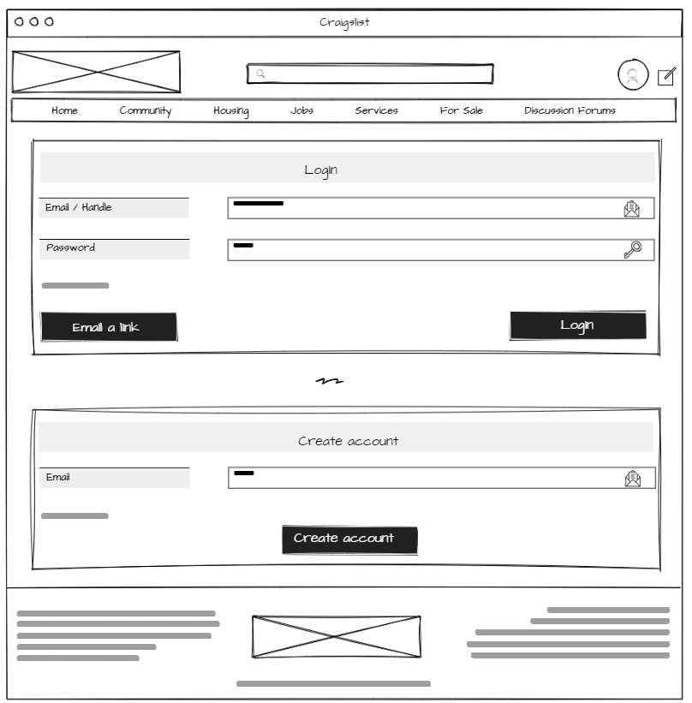

#### Account Login variant 2

#### THIS BEAUTIFUL COMBINATION FIREPLACE / 8-TRACK STEREO! variant 1

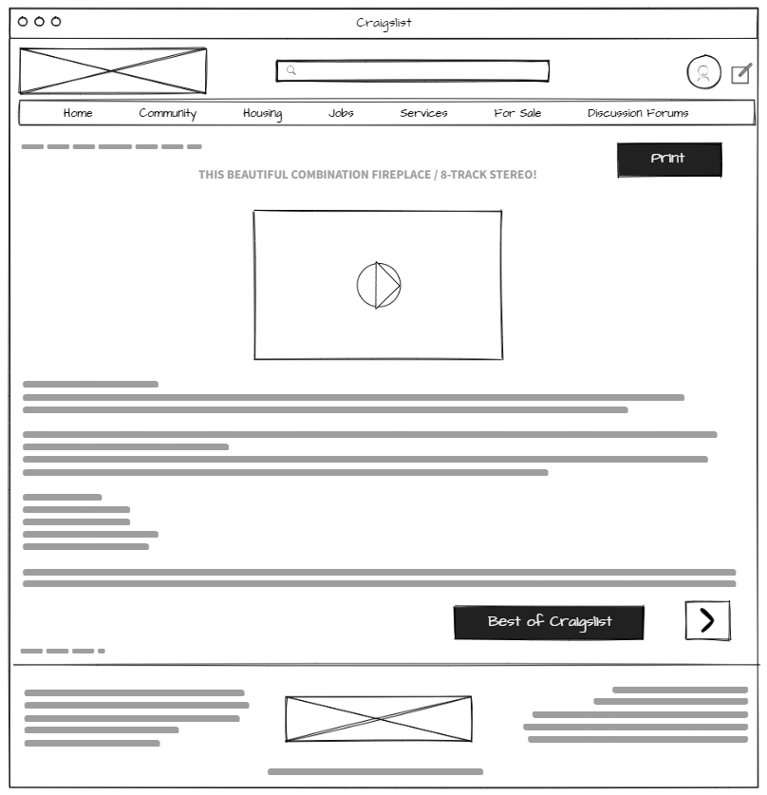

#### THIS BEAUTIFUL COMBINATION FIREPLACE / 8-TRACK STEREO! variant 2

#### Password option variant 1

#### Password option variant 2

#### Contact us variant 1.

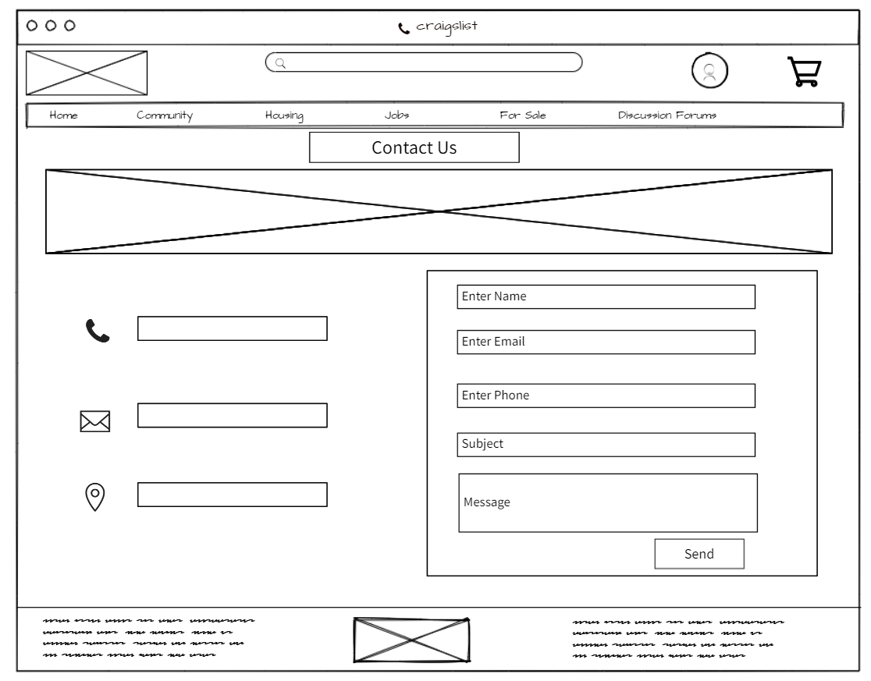

#### Contact us variant 2.

#### Community variant 1

#### Community variant 2

#### Profile variant 1

#### Profile variant 2

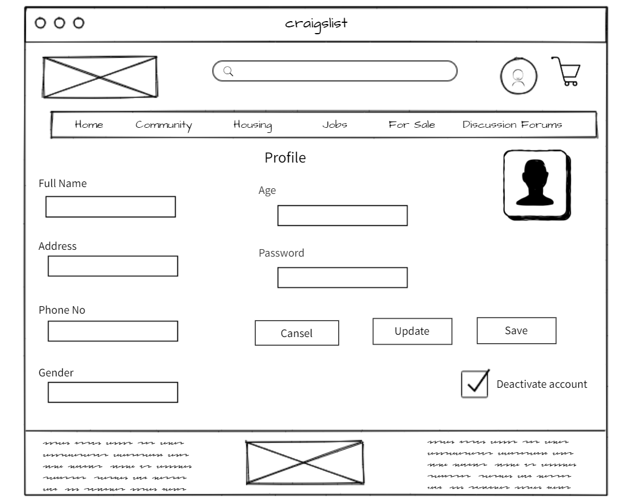

#### For sale variant 1

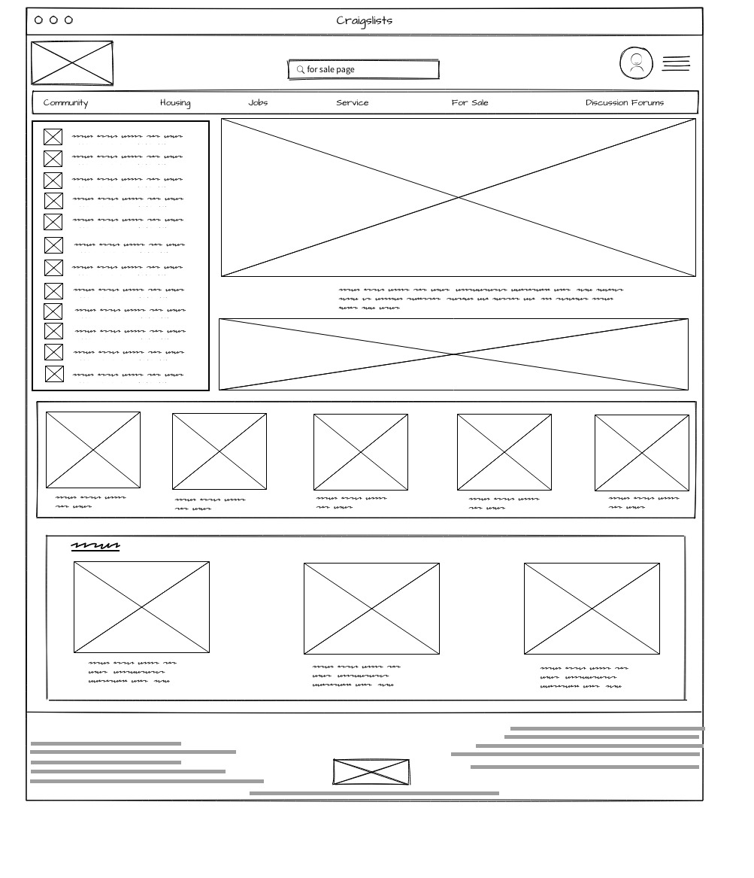

#### For sale variant 2

#### Services variant 1

#### Services variant 2

#### About variant 1

#### About variant 2

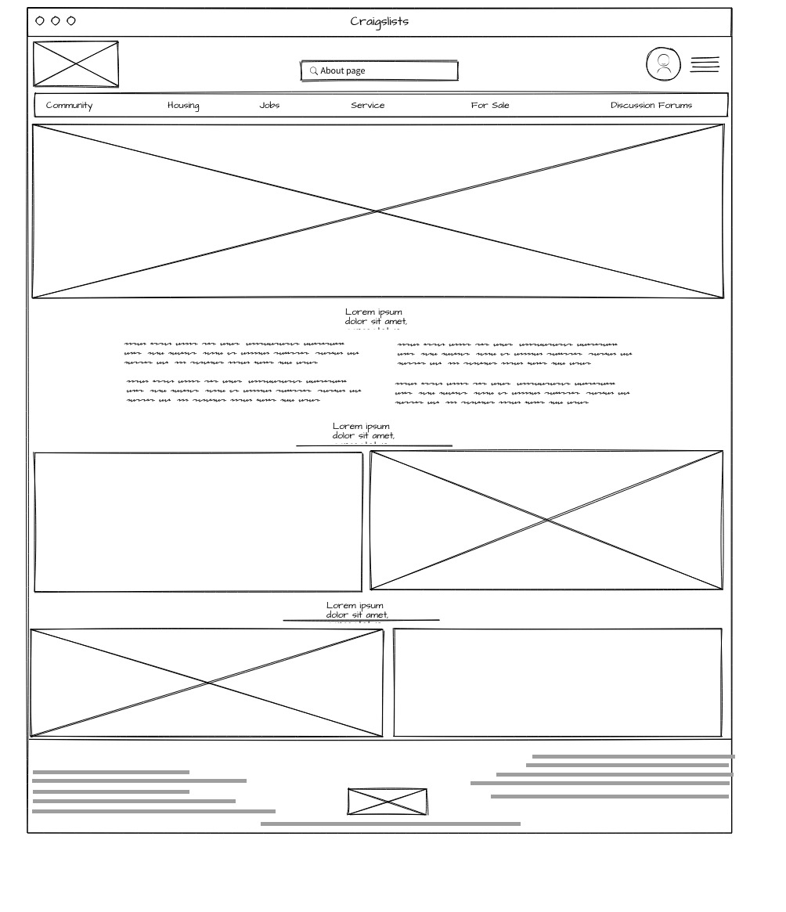

#### Post type and category variant 1

#### Post type and category variant 2

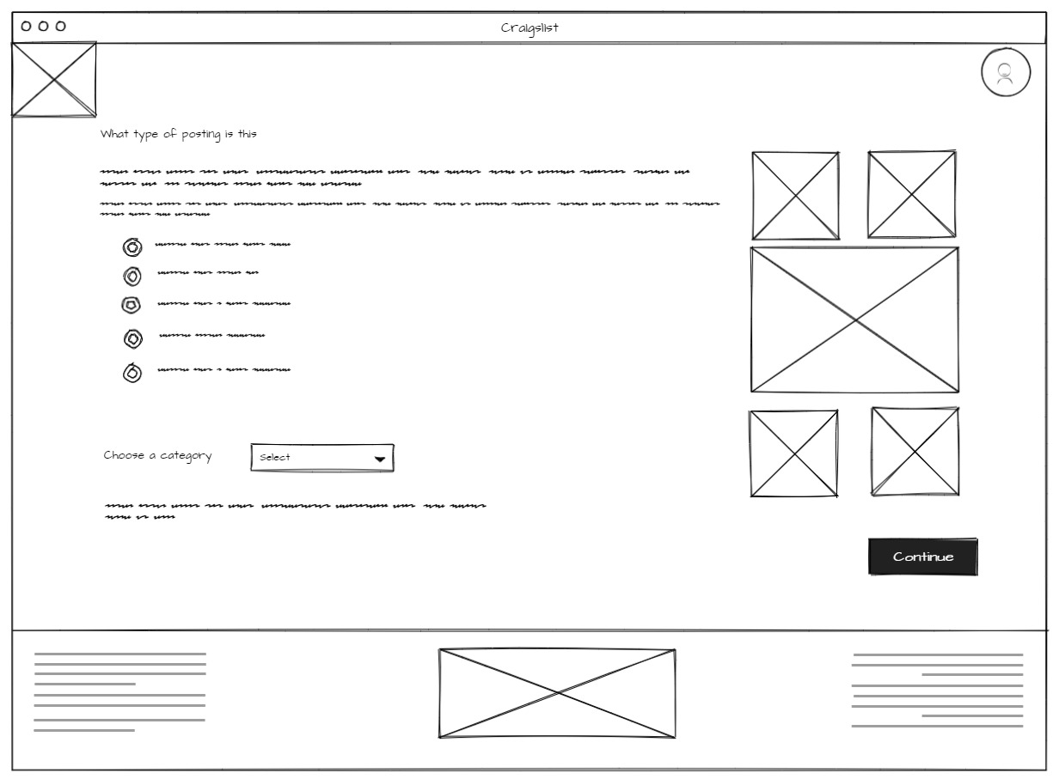

#### Post details fill page variant 1.

#### Post details fill page variant 2.

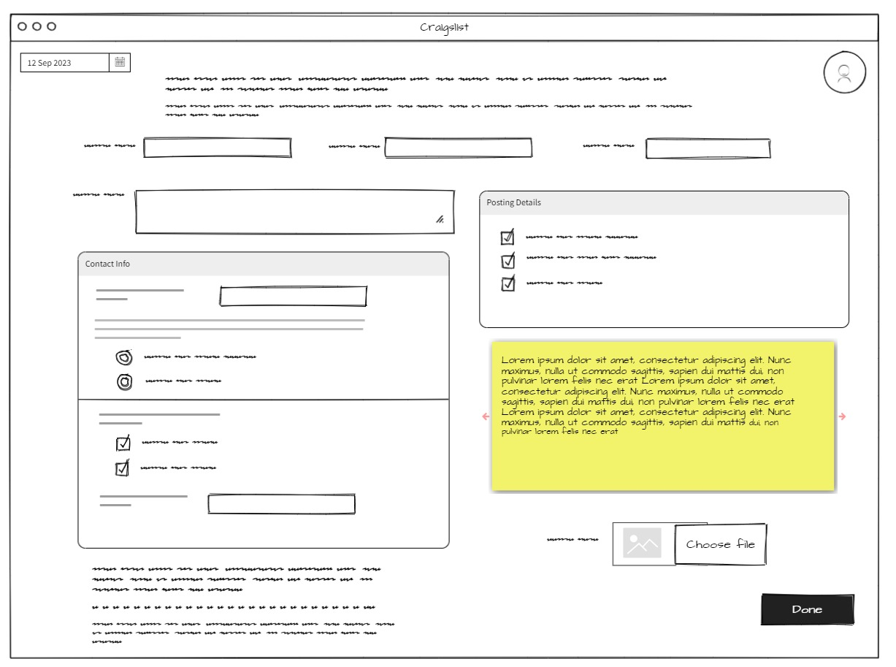

#### Unpublish draft page variant 1

#### Unpublish draft page variant 2

#### Homepage variant 1

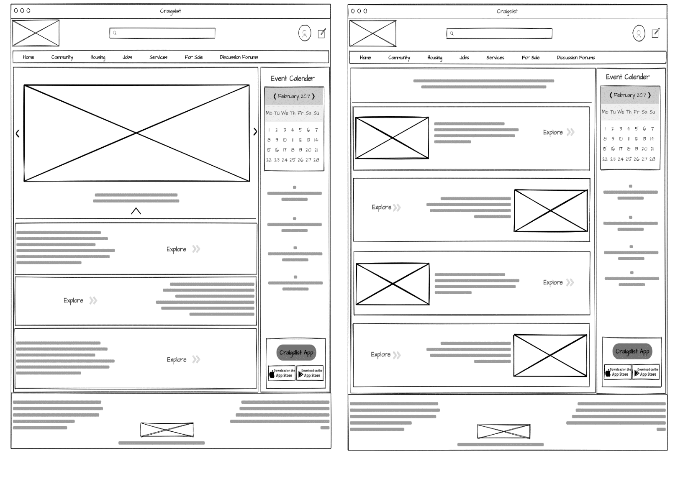

#### Homepage variant 2

#### Housing variant 1

#### Housing variant 2

#### Events variant 1

#### Events variant 2

